**Active Learning using BCNN**

* **Site A – 2019 -> Site B – 2020**

**Initial Test Results:**  Accuracy: 0.5519, Kappa: 0.2522, Average F1: 0.5040

Per-class F1: [0.506, 0.353, 0.653]

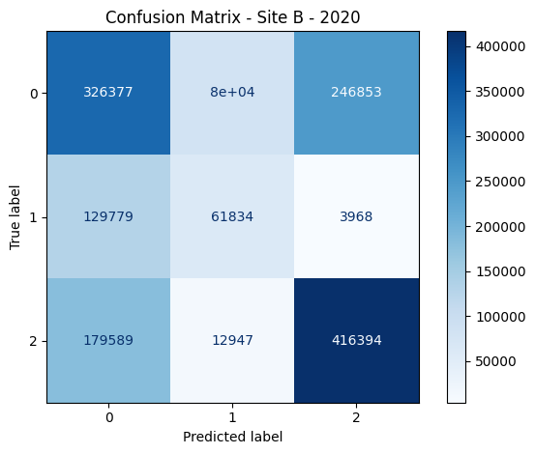

**Experiment 01:** Training on all of the training samples (25%) to get benchmark accuracy.

**Hyper-Parameters**

BATCH_SIZE = 64 PRIORS = {

NUM_CLASSES = 3 'prior_mu': 0,

LR = 1e-3 'prior_sigma': 0.1,

KL_WEIGHT = 1e-8 'posterior_mu_initial': (0.0, 0.1),

EPOCHS = 15 'posterior_rho_initial': (-3.0, 0.1)

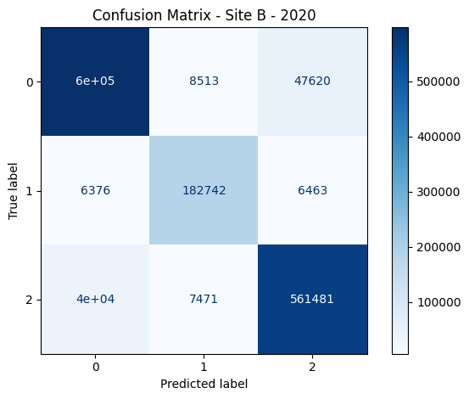 T = 15 }

**Results:** Accuracy: 0.9201, Kappa: 0.8685, Average F1: 0.9217

Per-class F1: [0.921, 0.927, 0.917]

**Conclusion:** On training on all 25% samples, we achieve a benchmark accuracy of 92% with 86.85% kappa.

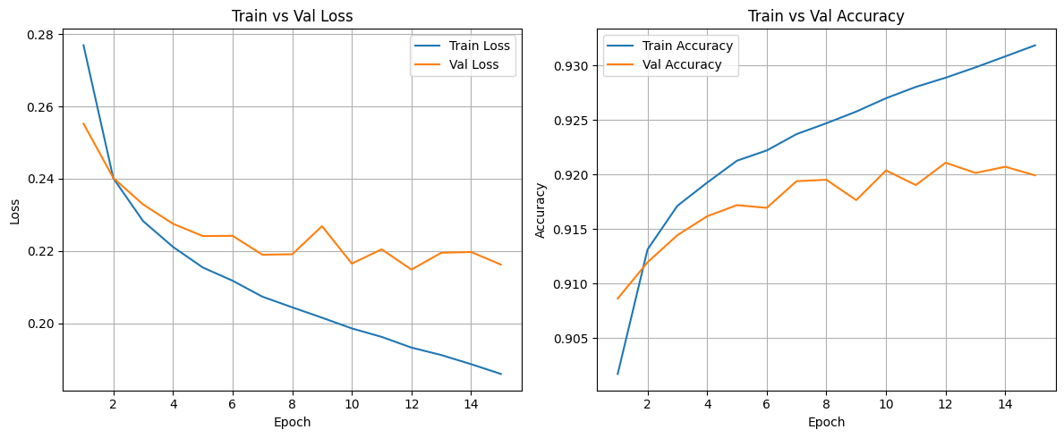

**Experiment 02:** Subsampled Training on training (25%) data with gap of 50,000.

**Hyper-Parameters**

BATCH_SIZE = 64 PRIORS = {

NUM_CLASSES = 3 'prior_mu': 0,

LR = 1e-3 'prior_sigma': 0.1,

KL_WEIGHT = 1e-8 'posterior_mu_initial': (0.0, 0.1),

EPOCHS = 5 'posterior_rho_initial': (-3.0, 0.1)

T = 5 }

|  |  |
| --- | --- |
| **Experiments** | **Results** |
| Labeled Samples: 50000 | **TrainAcc** = 91.41%, **TrainLoss** = 0.2451,  **ValAcc** = 90.67%, **ValLoss** = 0.2629 |
| Labeled Samples: 100000 | **TrainAcc** = 91.54%, **TrainLoss** = 0.2335,  **ValAcc** = 90.53%, **ValLoss** = 0.2558 |
| Labeled Samples: 150000 | **TrainAcc** = 91.76%, **TrainLoss** = 0.2285,  **ValAcc** = 91.20%, **ValLoss** = 0.2452 |
| Labeled Samples: 200000 | **TrainAcc** = 91.88%, **TrainLoss** = 0.2244,  **ValAcc** = 91.33%, **ValLoss** = 0.2359 |
| Labeled Samples: 250000 | **TrainAcc** = 91.94%, **TrainLoss** = 0.2209,  **ValAcc** = 91.60%, **ValLoss** = 0.2288 |
| Labeled Samples: 300000 | **TrainAcc** = 92.04%, **TrainLoss** = 0.2186,  **ValAcc** = 91.50%, **ValLoss** = 0.2303 |
| Labeled Samples: 350000 | **TrainAcc** = 92.06%, **TrainLoss** = 0.2168,  **ValAcc** = 91.60%, **ValLoss** = 0.2272 |

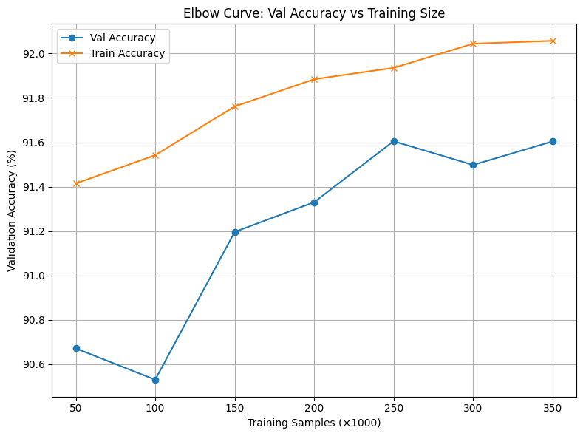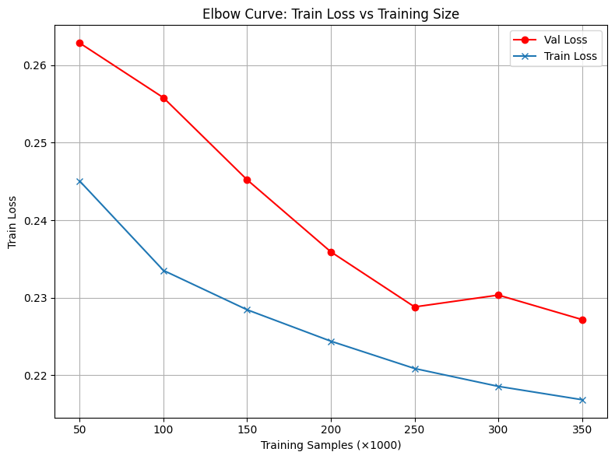

**Conclusion:** After 250,000 samples, the accuracy and loss doesn’t change much. So, I’ll take 250,000 samples and get the almost the same results as taking 350,000 samples.

**Experiment 03:** Subsampled Training on 250,000 samples with gap of 25,000.

**Hyper-Parameters**

BATCH_SIZE = 64 PRIORS = {

NUM_CLASSES = 3 'prior_mu': 0,

LR = 1e-3 'prior_sigma': 0.1,

KL_WEIGHT = 1e-8 'posterior_mu_initial': (0.0, 0.1),

EPOCHS = 10 'posterior_rho_initial': (-3.0, 0.1)

T = 10 }

|  |  |
| --- | --- |
| **Experiments** | **Results** |
| Labeled Samples: 25000 | **TrainAcc** = 92.91%, **TrainLoss** = 0.2090,  **ValAcc** = 90.10%, **ValLoss** = 0.2866,  **AvgF1** = 90.35%, **Kappa** = 0.8374 |
| Labeled Samples: 50000 | **TrainAcc** = 92.72%, **TrainLoss** = 0.2063,  **ValAcc** = 90.83%, **ValLoss** = 0.2613,  **AvgF1** = 91.07%, **Kappa** = 0.8490 |
| Labeled Samples: 75000 | **TrainAcc** = 92.68%, **TrainLoss** = 0.2047,  **ValAcc** = 91.04%, **ValLoss** = 0.2498,  **AvgF1** = 91.11%, **Kappa** = 0.8519 |
| Labeled Samples: 100000 | **TrainAcc** = 92.67%, **TrainLoss** = 0.2038,  **ValAcc** = 90.90%, **ValLoss** = 0.2484,  **AvgF1** = 91.14%, **Kappa** = 0.8514 |
| Labeled Samples: 125000 | **TrainAcc** = 92.56%, **TrainLoss** = 0.2045,  **ValAcc** = 91.13%, ValLoss = 0.2435,  **AvgF1** = 91.32%, **Kappa** = 0.8529 |
| Labeled Samples: 150000 | **TrainAcc** = 92.63%, **TrainLoss** = 0.2036,  **ValAcc** = 91.43%, **ValLoss** = 0.2344,  **AvgF1** = 91.63%, **Kappa** = 0.8592 |
| Labeled Samples: 175000 | **TrainAcc** = 92.61%, **TrainLoss** = 0.2034,  **ValAcc** = 91.63%, **ValLoss** = 0.2312,  **AvgF1** = 91.77%, **Kappa** = 0.8616 |
| Labeled Samples: 200000 | **TrainAcc** = 92.60%, **TrainLoss** = 0.2021,  **ValAcc** = 91.57%, **ValLoss** = 0.2333,  **AvgF1** = 91.87%, **Kappa** = 0.8613 |
| Labeled Samples: 225000 | **TrainAcc** = 92.63%, **TrainLoss** = 0.2021,  **ValAcc** = 91.37%, **ValLoss** = 0.2310,  **AvgF1** = 91.45%, **Kappa** = 0.8581 |
| Labeled Samples: 250000 | **TrainAcc** = 92.67%, **TrainLoss** = 0.2007,  **ValAcc** = 91.40%, **ValLoss** = 0.2294,  **AvgF1** = 91.49%, **Kappa** = 0.8583 |

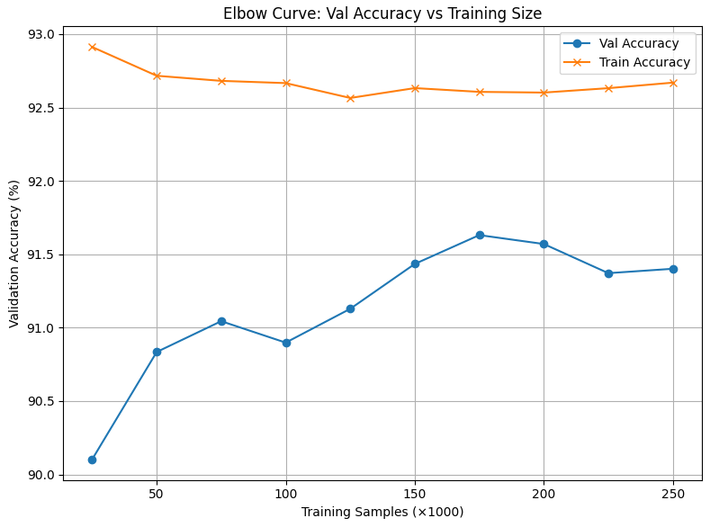

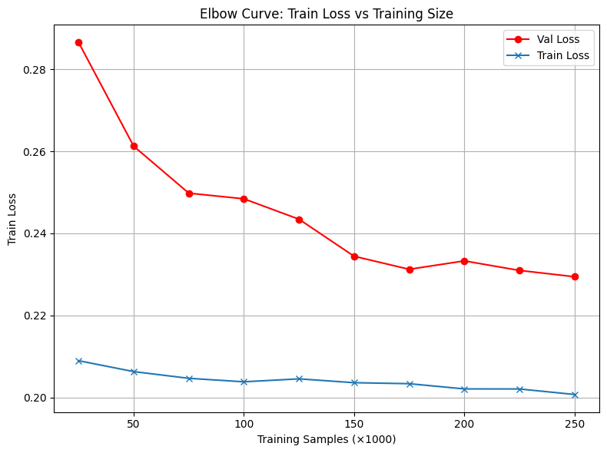

**Conclusion:** After 150,000 samples, the accuracy and loss doesn’t change much. So, I’ll take 150,000 samples and get the almost the same results as taking 250,000 samples.

**Experiment 04:** Subsampled Training on 150,000 samples with gap of 15,000.

**Hyper-Parameters**

BATCH_SIZE = 64 PRIORS = {

NUM_CLASSES = 3 'prior_mu': 0,

LR = 1e-3 'prior_sigma': 0.1,

KL_WEIGHT = 1e-8 'posterior_mu_initial': (0.0, 0.1),

EPOCHS = 15 'posterior_rho_initial': (-3.0, 0.1)

T = 15 }

|  |  |
| --- | --- |
| **Experiments** | **Results** |
| Labeled Samples: 15000 | **TrainAcc** = 95.49%, **TrainLoss** = 0.1478, **ValAcc** = 89.25%, **ValLoss** = 0.3453, **AvgF1** = 89.25%, **Kappa** = 0.8221 |
| Labeled Samples: 30000 | **TrainAcc** = 94.17%, **TrainLoss** = 0.1713, **ValAcc** = 89.98%, **ValLoss** = 0.3005, **AvgF1** = 90.28%, **Kappa** = 0.8358 |
| Labeled Samples: 45000 | **TrainAcc** = 93.97%, **TrainLoss** = 0.1751, **ValAcc** = 90.37%, **ValLoss** = 0.2876, **AvgF1** = 90.64%, **Kappa** = 0.8409 |
| Labeled Samples: 60000 | **TrainAcc** = 93.81%, **TrainLoss** = 0.1745, **ValAcc** = 90.30%, **ValLoss** = 0.2767, **AvgF1** = 90.40%, **Kappa** = 0.8413 |
| Labeled Samples: 75000 | **TrainAcc** = 93.63%, **TrainLoss** = 0.1805, **ValAcc** = 90.96%, **ValLoss** = 0.2656, **AvgF1** = 91.25%, **Kappa** = 0.8515 |
| Labeled Samples: 90000 | **TrainAcc** = 93.69%, **TrainLoss** = 0.1787, **ValAcc** = 90.77%, **ValLoss** = 0.2625, **AvgF1** = 90.75%, **Kappa** = 0.8488 |
| Labeled Samples: 105000 | **TrainAcc** = 93.57%, **TrainLoss** = 0.1806, **ValAcc** = 91.22%, **ValLoss** = 0.2538, **AvgF1** = 91.56%, **Kappa** = 0.8561 |
| Labeled Samples: 120000 | **TrainAcc** = 93.48%, **TrainLoss** = 0.1823, **ValAcc** = 91.03%, **ValLoss** = 0.2574, **AvgF1** = 91.18%, **Kappa** = 0.8501 |
| Labeled Samples: 135000 | **TrainAcc** = 93.43%, **TrainLoss** = 0.1835, **ValAcc** = 91.55%, **ValLoss** = 0.2414, **AvgF1** = 91.82%, **Kappa** = 0.8612 |
| Labeled Samples: 150000 | **TrainAcc** = 93.42%, **TrainLoss** = 0.1845, **ValAcc** = 91.24%, **ValLoss** = 0.2417, **AvgF1** = 91.30%, **Kappa** = 0.8561 |

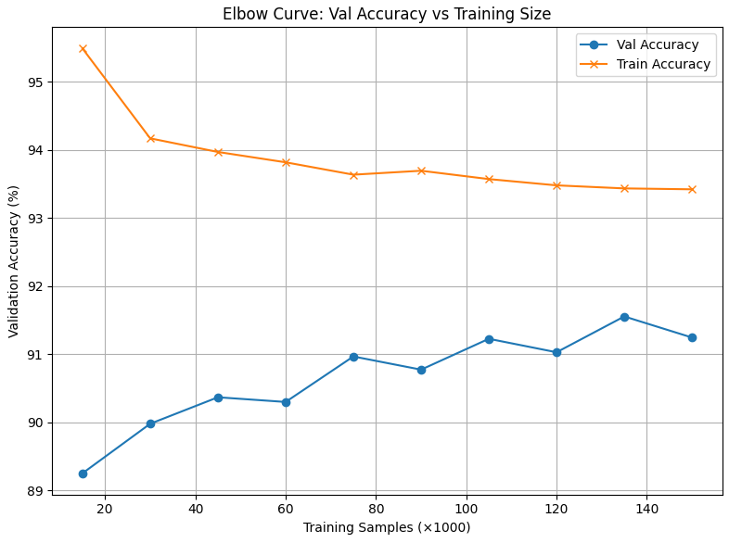

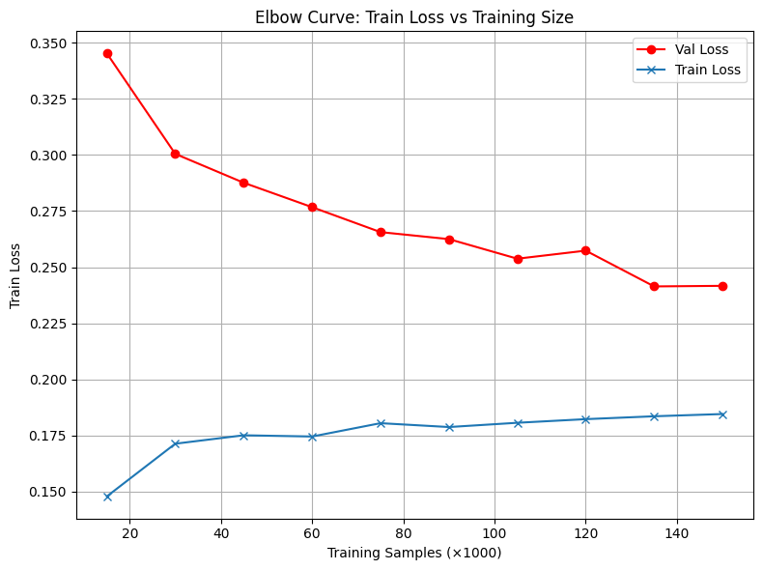

**Conclusion:** After 75,000 samples, the accuracy and loss doesn’t change much. So, I’ll take 75,000 samples and get the almost the same results as taking 150,000 samples.

**Experiment 05:** Subsampled Training on 75,000 samples with gap of 5,000.

**Hyper-Parameters**

BATCH_SIZE = 64 PRIORS = {

NUM_CLASSES = 3 'prior_mu': 0,

LR = 1e-3 'prior_sigma': 0.1,

KL_WEIGHT = 1e-8 'posterior_mu_initial': (0.0, 0.1),

EPOCHS = 15 'posterior_rho_initial': (-3.0, 0.1)

T = 15 }

|  |  |
| --- | --- |
| **Experiments** | **Results** |
| Labeled Samples: 5000 | **TrainAcc** = 95.14%, **TrainLoss** = 0.1624, **ValAcc** = 87.47%, **ValLoss** = 0.3916, **AvgF1** = 88.16%, **Kappa** = 0.7946 |
| Labeled Samples: 10000 | **TrainAcc** = 95.39%, **TrainLoss** = 0.1449, **ValAcc** = 89.14%, **ValLoss** = 0.3597, **AvgF1** = 89.41%, **Kappa** = 0.8212 |
| Labeled Samples: 15000 | **TrainAcc** = 95.09%, **TrainLoss** = 0.1545, **ValAcc** = 89.50%, **ValLoss** = 0.3376, **AvgF1** = 89.81%, **Kappa** = 0.8267 |
| Labeled Samples: 20000 | **TrainAcc** = 94.88%, **TrainLoss** = 0.1598, **ValAcc** = 89.78%, **ValLoss** = 0.3163, **AvgF1** = 90.03%, **Kappa** = 0.8313 |
| Labeled Samples: 25000 | **TrainAcc** = 94.64%, **TrainLoss** = 0.1638, **ValAcc** = 89.39%, **ValLoss** = 0.3245, **AvgF1** = 89.62%, **Kappa** = 0.8267 |
| Labeled Samples: 30000 | **TrainAcc** = 94.28%, **TrainLoss** = 0.1695, **ValAcc** = 90.05%, **ValLoss** = 0.3056, **AvgF1** = 90.24%, **Kappa** = 0.8364 |
| Labeled Samples: 35000 | **TrainAcc** = 93.97%, **TrainLoss** = 0.1750, **ValAcc** = 89.93%, **ValLoss** = 0.3004, **AvgF1** = 90.13%, **Kappa** = 0.8326 |
| Labeled Samples: 40000 | **TrainAcc** = 94.11%, **TrainLoss** = 0.1722, **ValAcc** = 90.11%, **ValLoss** = 0.2930, **AvgF1** = 90.32%, **Kappa** = 0.8367 |
| Labeled Samples: 45000 | **TrainAcc** = 93.97%, **TrainLoss** = 0.1744, **ValAcc** = 90.02%, **ValLoss** = 0.2936, **AvgF1** = 90.21%, **Kappa** = 0.8369 |
| Labeled Samples: 50000 | **TrainAcc** = 93.91%, **TrainLoss** = 0.1737, **ValAcc** = 90.34%, **ValLoss** = 0.2902, **AvgF1** = 90.52%, **Kappa** = 0.8420 |
| Labeled Samples: 55000 | **TrainAcc** = 93.91%, **TrainLoss** = 0.1743, **ValAcc** = 90.39%, **ValLoss** = 0.2852, **AvgF1** = 90.54%, **Kappa** = 0.8439 |
| Labeled Samples: 60000 | **TrainAcc** = 93.78%, **TrainLoss** = 0.1755, **ValAcc** = 90.52%, **ValLoss** = 0.2768, **AvgF1** = 90.77%, **Kappa** = 0.8429 |
| Labeled Samples: 65000 | **TrainAcc** = 93.85%, **TrainLoss** = 0.1756, **ValAcc** = 90.82%, **ValLoss** = 0.2700, **AvgF1** = 90.98%, **Kappa** = 0.8484 |
| Labeled Samples: 70000 | **TrainAcc** = 93.87%, **TrainLoss** = 0.1770, **ValAcc** = 90.78%, **ValLoss** = 0.2668, **AvgF1** = 90.91%, **Kappa** = 0.8490 |
| Labeled Samples: 75000 | **TrainAcc** = 93.70%, **TrainLoss** = 0.1789, **ValAcc** = 89.52%, **ValLoss** = 0.2928, **AvgF1** = 90.11%, **Kappa** = 0.8311 |

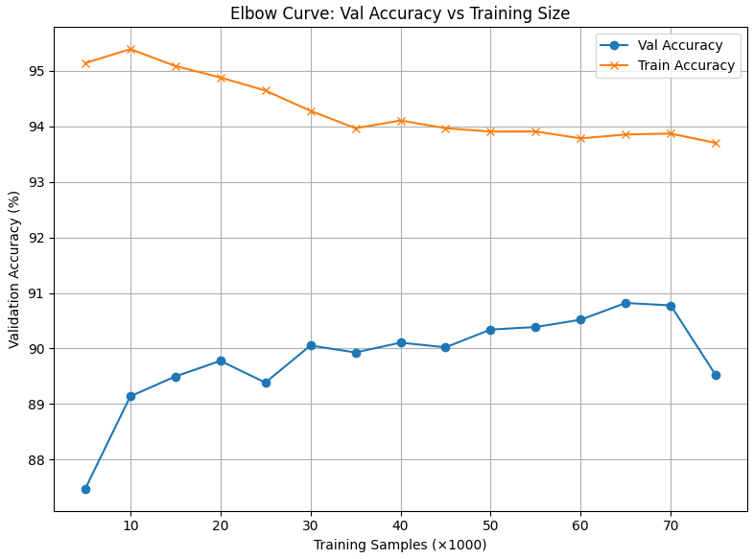

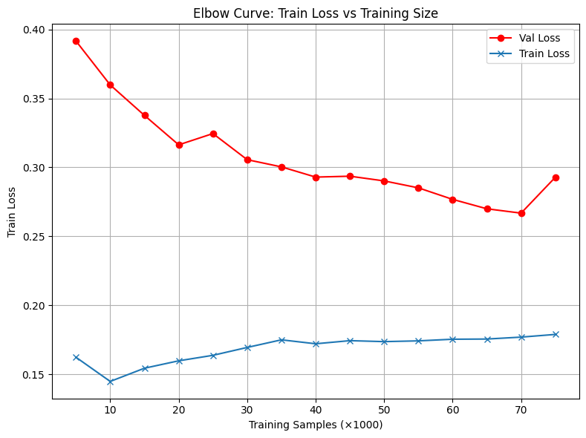

**Conclusion:** After 30,000 samples, the accuracy and loss doesn’t change much. So, I’ll take 30,000 samples and get the almost the same results as taking 75,000 samples.

**Experiment 06:** Subsampled Training on 30,000 samples with gap of 3,000.

**Hyper-Parameters**

BATCH_SIZE = 64 PRIORS = {

NUM_CLASSES = 3 'prior_mu': 0,

LR = 1e-3 'prior_sigma': 0.1,

KL_WEIGHT = 1e-8 'posterior_mu_initial': (0.0, 0.1),

EPOCHS = 15 'posterior_rho_initial': (-3.0, 0.1)

T = 15 }

|  |  |
| --- | --- |
| **Experiments** | **Results** |
| Labeled Samples: 3000 | **TrainAcc** = 96.57%, **TrainLoss** = 0.1383, **ValAcc** = 87.57%, **ValLoss** = 0.3904, **AvgF1** = 88.01%, **Kappa** = 0.7937 |
| Labeled Samples: 6000 | **TrainAcc** = 95.68%, **TrainLoss** = 0.1436, **ValAcc** = 88.63%, **ValLoss** = 0.3761, **AvgF1** = 89.07%, **Kappa** = 0.8136 |
| Labeled Samples: 9000 | **TrainAcc** = 95.79%, **TrainLoss** = 0.1414, **ValAcc** = 88.83%, **ValLoss** = 0.3506, **AvgF1** = 89.19%, **Kappa** = 0.8173 |
| Labeled Samples: 12000 | **TrainAcc** = 95.60%, **TrainLoss** = 0.1453, **ValAcc** = 88.98%, **ValLoss** = 0.3545, **AvgF1** = 89.32%, **Kappa** = 0.8171 |
| Labeled Samples: 15000 | **TrainAcc** = 95.18%, **TrainLoss** = 0.1529, **ValAcc** = 89.49%, **ValLoss** = 0.3366, **AvgF1** = 89.82%, **Kappa** = 0.8285 |
| Labeled Samples: 18000 | **TrainAcc** = 94.84%, **TrainLoss** = 0.1609, **ValAcc** = 89.47%, **ValLoss** = 0.3270, **AvgF1** = 89.88%, **Kappa** = 0.8266 |
| Labeled Samples: 21000 | **TrainAcc** = 94.81%, **TrainLoss** = 0.1639, **ValAcc** = 89.54%, **ValLoss** = 0.3203, **AvgF1** = 89.97%, **Kappa** = 0.8280 |
| Labeled Samples: 24000 | **TrainAcc** = 94.55%, **TrainLoss** = 0.1676, **ValAcc** = 89.91%, **ValLoss** = 0.3122, **AvgF1** = 90.27%, **Kappa** = 0.8337 |
| Labeled Samples: 27000 | **TrainAcc** = 94.47%, **TrainLoss** = 0.1685, **ValAcc** = 89.70%, **ValLoss** = 0.3079, **AvgF1** = 90.11%, **Kappa** = 0.8306 |
| Labeled Samples: 30000 | **TrainAcc** = 94.39%, **TrainLoss** = 0.1663, **ValAcc** = 89.53%, **ValLoss** = 0.3174, **AvgF1** = 89.94%, **Kappa** = 0.8294 |

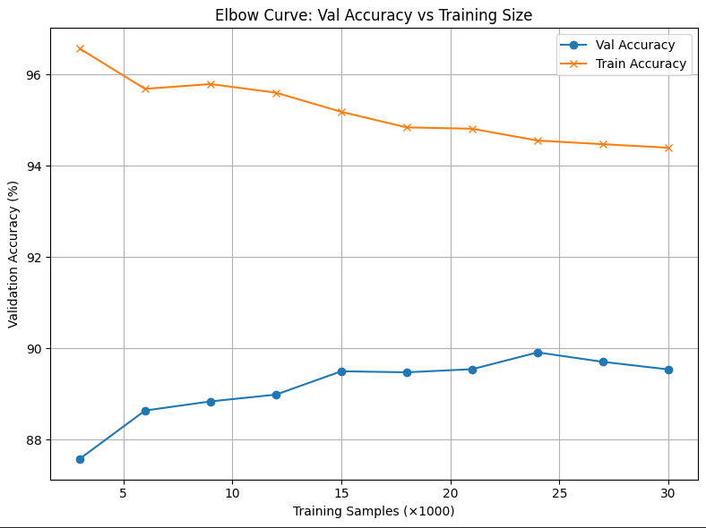

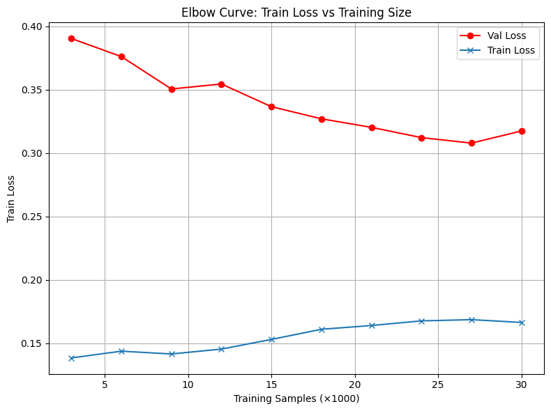

**Experiment 07:** Subsampled Training on 15,000 samples with gap of 1,000.

**Hyper-Parameters**

BATCH_SIZE = 64 PRIORS = {

NUM_CLASSES = 3 'prior_mu': 0,

LR = 1e-3 'prior_sigma': 0.1,

KL_WEIGHT = 1e-8 'posterior_mu_initial': (0.0, 0.1),

EPOCHS = 15 'posterior_rho_initial': (-3.0, 0.1)

T = 15 }

|  |  |
| --- | --- |
| **Experiments** | **Results** |
| Labeled Samples: 1000 | **TrainAcc** = 95.40%, **TrainLoss** = 0.1725, **ValAcc** = 86.36%, **ValLoss** = 0.4080, **AvgF1** = 86.84%, **Kappa** = 0.7754 |
| Labeled Samples: 2000 | **TrainAcc** = 95.10%, **TrainLoss** = 0.1557, **ValAcc** = 86.80%, **ValLoss** = 0.4111, **AvgF1** = 87.40%, **Kappa** = 0.7827 |
| Labeled Samples: 3000 | **TrainAcc** = 95.83%, **TrainLoss** = 0.1440, **ValAcc** = 87.63%, **ValLoss** = 0.3969, **AvgF1** = 88.08%, **Kappa** = 0.7973 |
| Labeled Samples: 4000 | **TrainAcc** = 95.45%, **TrainLoss** = 0.1509, **ValAcc** = 87.85%, **ValLoss** = 0.3808, **AvgF1** = 88.39%, **Kappa** = 0.7999 |
| Labeled Samples: 5000 | **TrainAcc** = 95.46%, **TrainLoss** = 0.1528, **ValAcc** = 88.23%, **ValLoss** = 0.3708, **AvgF1** = 88.55%, **Kappa** = 0.8050 |
| Labeled Samples: 6000 | **TrainAcc** = 96.05%, **TrainLoss** = 0.1398, **ValAcc** = 88.17%, **ValLoss** = 0.3767, **AvgF1** = 88.50%, **Kappa** = 0.8044 |
| Labeled Samples: 7000 | **TrainAcc** = 95.74%, **TrainLoss** = 0.1393, **ValAcc** = 88.57%, **ValLoss** = 0.3709, **AvgF1** = 88.82%, **Kappa** = 0.8105 |
| Labeled Samples: 8000 | **TrainAcc** = 95.75%, **TrainLoss** = 0.1395, **ValAcc** = 88.89%, **ValLoss** = 0.3617, **AvgF1** = 89.05%, **Kappa** = 0.8157 |
| Labeled Samples: 9000 | **TrainAcc** = 95.51%, **TrainLoss** = 0.1437, **ValAcc** = 89.07%, **ValLoss** = 0.3523, **AvgF1** = 89.45%, **Kappa** = 0.8194 |
| Labeled Samples: 10000 | **TrainAcc** = 95.25%, **TrainLoss** = 0.1530, **ValAcc** = 88.56%, **ValLoss** = 0.3696, **AvgF1** = 88.88%, **Kappa** = 0.8113 |
| Labeled Samples: 11000 | **TrainAcc** = 95.58%, **TrainLoss** = 0.1451, **ValAcc** = 88.56%, **ValLoss** = 0.3596, **AvgF1** = 88.95%, **Kappa** = 0.8115 |
| Labeled Samples: 12000 | **TrainAcc** = 95.43%, **TrainLoss** = 0.1493, **ValAcc** = 89.15%, **ValLoss** = 0.3528, **AvgF1** = 89.37%, **Kappa** = 0.8194 |
| Labeled Samples: 13000 | **TrainAcc** = 95.35%, **TrainLoss** = 0.1530, **ValAcc** = 89.04%, **ValLoss** = 0.3463, **AvgF1** = 89.27%, **Kappa** = 0.8193 |
| Labeled Samples: 14000 | **TrainAcc** = 95.17%, **TrainLoss** = 0.1518, **ValAcc** = 89.37%, **ValLoss** = 0.3403, **AvgF1** = 89.63%, **Kappa** = 0.8246 |
| Labeled Samples: 15000 | **TrainAcc** = 95.13%, **TrainLoss** = 0.1539, **ValAcc** = 89.53%, **ValLoss** = 0.3390, **AvgF1** = 90.00%, **Kappa** = 0.8287 |

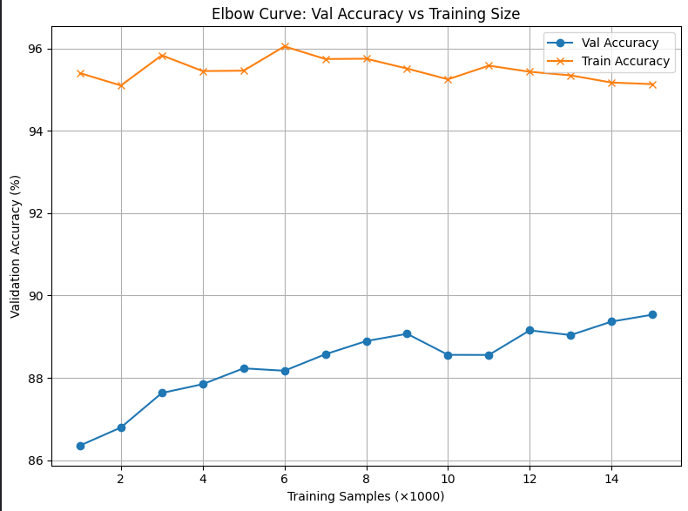

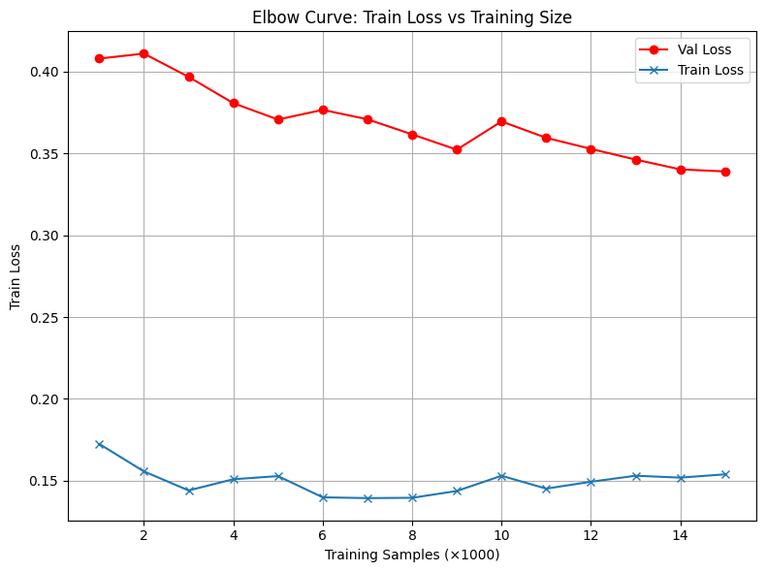

**Conclusion:** In between 13,000 to 16,000, there is 1% decrease in AvgF1. So now exploring the samples between them with a step of 300.

**Experiment 08:** Subsampled Training on samples between 13,000 and 16,000 with gap of 300.

**Hyper-Parameters**

BATCH_SIZE = 64 PRIORS = {

NUM_CLASSES = 3 'prior_mu': 0,

LR = 1e-3 'prior_sigma': 0.1,

KL_WEIGHT = 1e-8 'posterior_mu_initial': (0.0, 0.1),

EPOCHS = 15 'posterior_rho_initial': (-3.0, 0.1)

T = 15 }

|  |  |
| --- | --- |
| **Experiments** | **Results** |
| Labeled Samples: 13000 | **TrainAcc** = 95.12%, **TrainLoss** = 0.1539, **ValAcc** = 88.64%, **ValLoss** = 0.3473, **AvgF1** = 89.03%, **Kappa** = 0.8132 |
| Labeled Samples: 13300 | **TrainAcc** = 95.38%, **TrainLoss** = 0.1475, **ValAcc** = 89.29%, **ValLoss** = 0.3461, **AvgF1** = 89.54%, **Kappa** = 0.8234 |
| Labeled Samples: 13600 | **TrainAcc** = 95.24%, **TrainLoss** = 0.1544, **ValAcc** = 89.34%, **ValLoss** = 0.3414, **AvgF1** = 89.57%, **Kappa** = 0.8233 |
| Labeled Samples: 13900 | **TrainAcc** = 95.38%, **TrainLoss** = 0.1520, **ValAcc** = 89.48%, **ValLoss** = 0.3292, **AvgF1** = 89.69%, **Kappa** = 0.8261 |
| Labeled Samples: 14200 | **TrainAcc** = 95.27%, **TrainLoss** = 0.1485, **ValAcc** = 89.59%, **ValLoss** = 0.3393, **AvgF1** = 89.92%, **Kappa** = 0.8273 |
| Labeled Samples: 14500 | **TrainAcc** = 95.12%, **TrainLoss** = 0.1549, **ValAcc** = 89.63%, **ValLoss** = 0.3247, **AvgF1** = 89.83%, **Kappa** = 0.8276 |
| Labeled Samples: 14800 | **TrainAcc** = 95.22%, **TrainLoss** = 0.1504, **ValAcc** = 89.52%, **ValLoss** = 0.3383, **AvgF1** = 89.89%, **Kappa** = 0.8267 |
| Labeled Samples: 15100 | **TrainAcc** = 95.21%, **TrainLoss** = 0.1494, **ValAcc** = 89.19%, **ValLoss** = 0.3403, **AvgF1** = 89.43%, **Kappa** = 0.8224 |
| Labeled Samples: 15400 | **TrainAcc** = 95.03%, **TrainLoss** = 0.1559, **ValAcc** = 88.59%, **ValLoss** = 0.3504, **AvgF1** = 88.89%, **Kappa** = 0.8127 |
| Labeled Samples: 15700 | **TrainAcc** = 95.19%, **TrainLoss** = 0.1495, **ValAcc** = 89.53%, **ValLoss** = 0.3281, **AvgF1** = 89.83%, **Kappa** = 0.8279 |
| Labeled Samples: 16000 | **TrainAcc** = 95.09%, **TrainLoss** = 0.1542, **ValAcc** = 89.45%, **ValLoss** = 0.3299, **AvgF1** = 89.72%, **Kappa** = 0.8262 |

